Overview

This document describes the features and functions of Starfish™ as they relate to online appointment scheduling, services, and calendar integration with Microsoft® Exchange™ or Google.
Online Scheduling
Key Concepts: Appointment Type Configurations
Configure Appointment Types
Where Do Appointment Types Display in Starfish?
Where Do SpeedNotes Display in Starfish?
Configure Services
Role Mapping
Configure who can view the Services Catalog
Integration with Microsoft Exchange or Google Calendar

Online Scheduling

Starfish supports Two-Way Calendar Communication with most online calendars (e.g., Microsoft Outlook, Google). When an appointment is scheduled or updated in Starfish, a calendar invitation (with iCal attachment) is sent to both parties (the student and the calendar owner) and users can accept or decline in their email client. This two-way integration is automatically available and requires no additional integration or installation.
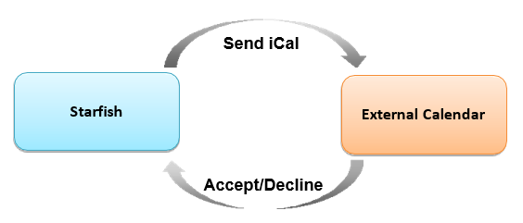

When the Starfish Calendar is updated: Starfish triggers an updated calendar invitation (iCal) when the following updates are made in Starfish:
- New or updated block of time available for student appointments
- Student appointment scheduled
- Student appointment changed
- Student appointment canceled

When an invitation is canceled or declined: When a user cancels or declines a Starfish invitation from their external calendar (i.e., Microsoft Outlook), the cancel/decline is sent to Starfish and reflected on the Starfish calendar.

Dependencies
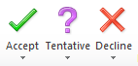 | Users must utilize online calendars that allow calendar invitations and iCal attachments, such as Microsoft Outlook, Google Calendar, etc.
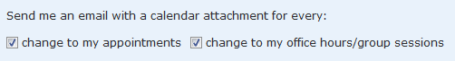 | A user must allow email notifications in their Starfish profile. These settings are enabled by default and recommended but can be changed on a user-by-user basis.  We recommend all users select the Change to my appointments checkbox.  If you have your entire workday open for office hours, we do not recommend selecting the Change to my office hours/group sessions checkbox.

Key Concepts: Appointment Type Configurations

- Starfish Admins configure Appointment Types and grants appropriate roles permissions to utilize each type.
- Starfish Admins associate a set of reasons to each Appointment Type.
- Staff members (calendar owners) create Office Hours in the Starfish Calendar and specify which Appointment Types apply to those blocks of time.
- When the student makes an appointment, they select from the available reasons and time slots based on what the Starfish Admin has configured, and what each staff member has set up for their Office Hours. (See Service Provider Display for more.)

Configure Appointment Types

Roles and relationships must exist in your system prior to configuring the following features. Information on roles and relationships can be found in the Guide to Roles and Relationships which is also available on the Starfish Help Center.

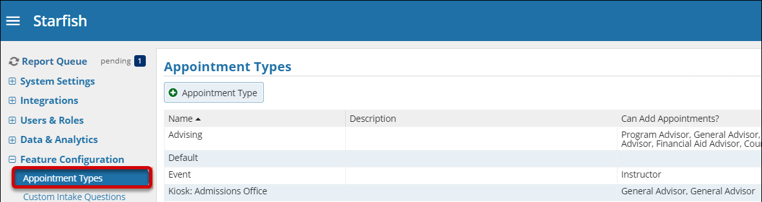

- Navigate to Starfish Admin > Feature Configuration > Appointment Types.

- Select Add Appointment Type. To edit an existing appointment type, select the Edit icon.
Tip: Appointment Types pull into Starfish reports. If you know you will need to report on Advising appointments separately from Tutoring appointments, make sure you have created separate Appointment Types.

- Enter the name of the appointment in the Appointment Type field. The name is visible to faculty, staff, and students.

- (Optional) Enter the description in the Description field. The description is only visible to Starfish Admins. When finished, select Next.

Properties Tab

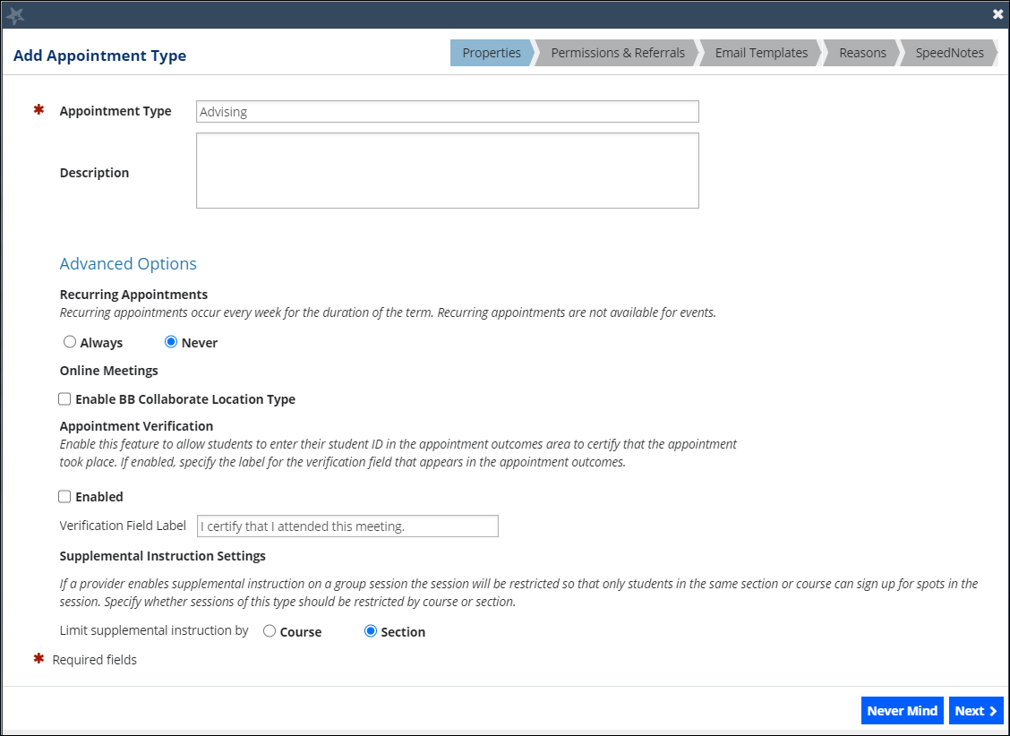

Advanced Options
Item | Description
Recurring Appointments | Always: If selected, this appointment type is always allowed to have recurring appointments.  Never: If selected, this appointment type is never allowed to have recurring appointments.
Online Meetings | This option is no longer a supported integration and can be ignored. If you have access to appointment types, you can add online meeting options in the Add Location section of your Starfish Profile.
Appointment Verification | This option is no longer a supported integration and can be ignored.
Supplemental Instruction Settings | Course: If selected, only students in the course can sign up for spots in the session.  Section: If selected, only students in the section can sign up for spots in the session.

- When finished, select Next.

Permissions & Referrals Tab

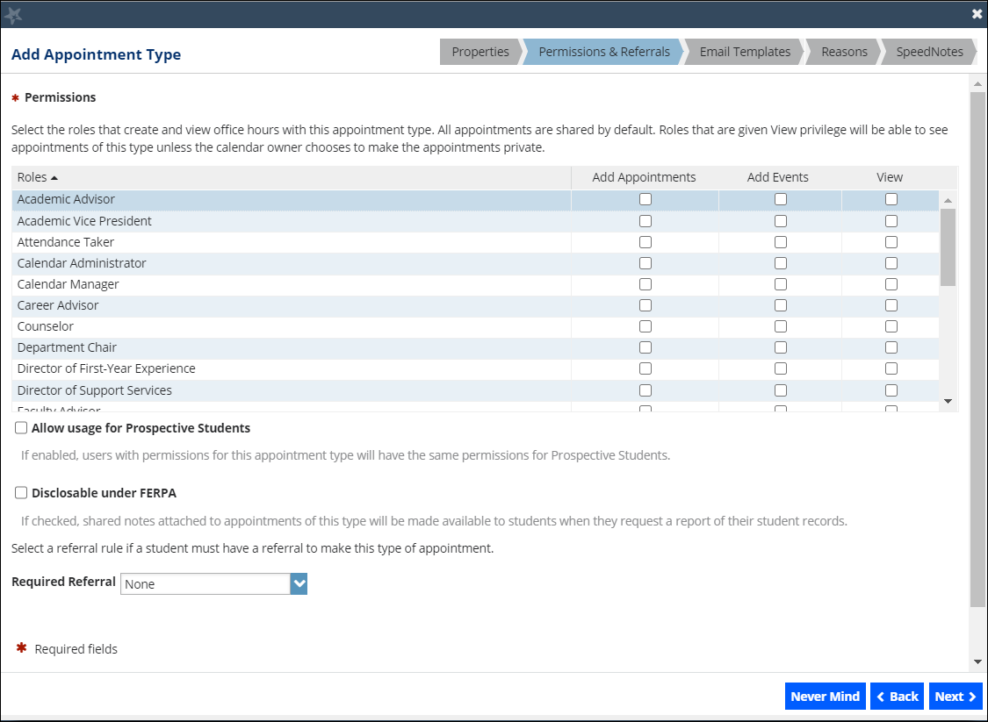
- Check the appropriate boxes to assign roles and permissions.

Tip: If a Role has access to view an Appointment Type, users in that Role will be able to see any appointments of that type for the students they have a Relationship within Starfish.

- Select Allow usage for Prospective Students, if users with permissions for this appointment type can view/create appointments for prospective students.

- Select Disclosable under FERPA if shared notes attached to appointments of this type will be made available to students when they request a report of the student records.

- Select the Required Referral dropdown to limit the students who can schedule appointments of this type if they have a referral. A student must have an active referral to schedule the appointment.
Tip: If students must sign up for tutoring prior to scheduling appointments, consider using a Required Referral to limit the students who are eligible to schedule. After the student completes the application process, staff can assign the student to the designated Referral. Then the student can schedule this type of appointment.

- When finished, select Next.

Email Templates Tab

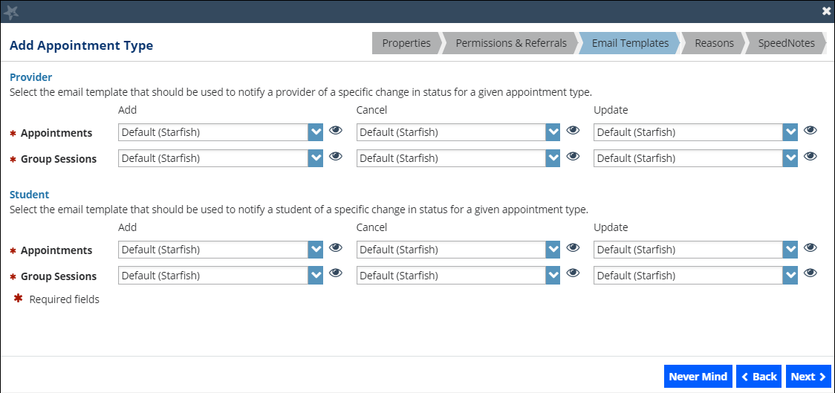

Provider Email Templates
- Select the appropriate Appointments and Group Sessions Message Template dropdowns. (For more on Message Templates see the Starfish Help Center.)
Student Email Templates
- Select the appropriate Appointments and Group Sessions Message Template dropdowns. (For more on Message Templates see the Starfish Help Center.)

- When finished, select Next.

Reasons Tab

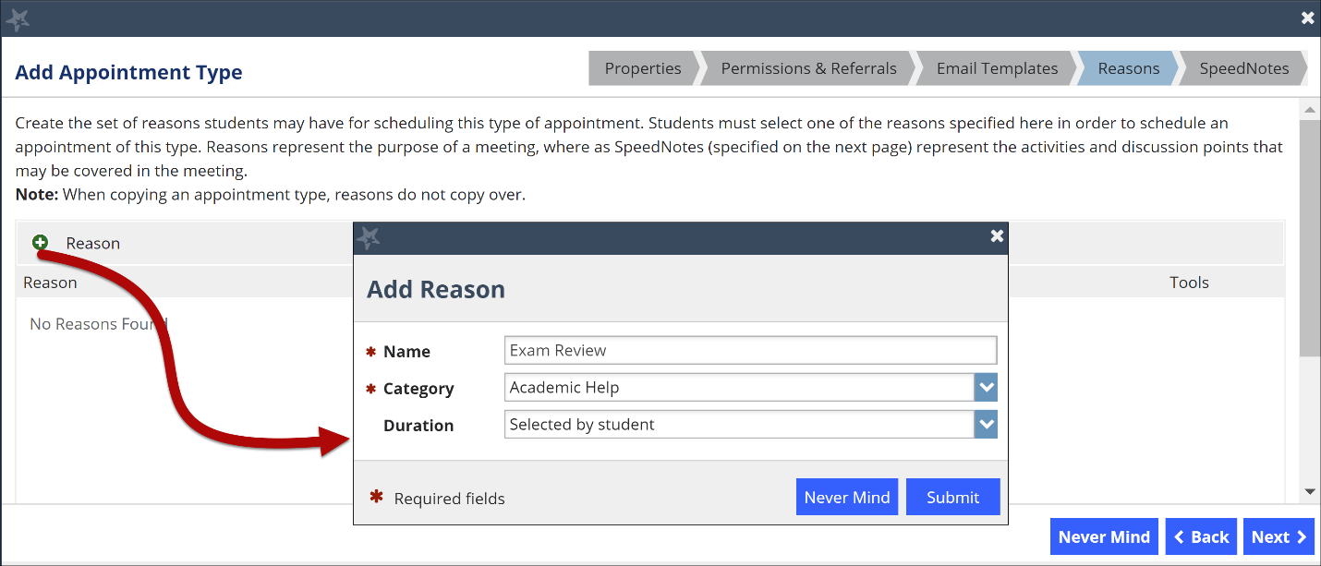
- Select +Reason to populate the list of reasons associated with this Appointment Type when the student selects the Reason dropdown. Students must select one of the reasons specified here to schedule an appointment of this type.
- Enter a Name for the Reason dropdown. This field is visible to the student.
- Select a Category. This field is not visible to the student and is for reporting purposes only. The options in this field are not editable.
- (Optional) Select a Duration. Choose Selected by student if there is no predetermined amount of time for this appointment reason.
- Repeat these steps, as necessary.
Tip: If first year advising appointments must always be 60 minutes, consider locking the duration associated with the reason code to prevent incorrect appointments from being scheduled.
Key Concept: Reasons represent the purpose of the meeting, whereas SpeedNotes (specified on the next step) represent the activities and discussion points that may be covered in the meeting.

Where Do Appointment Types Display in Starfish?

Appointment Types display on the Add Office Hours, Edit Service, and Edit Kiosk screens. Calendar owners with access to more than one appointment type will be given a choice of which appointment type(s) to link to their office hour blocks. The Appointment Types selected determines which students can schedule during this time, and which reasons the students can choose from.
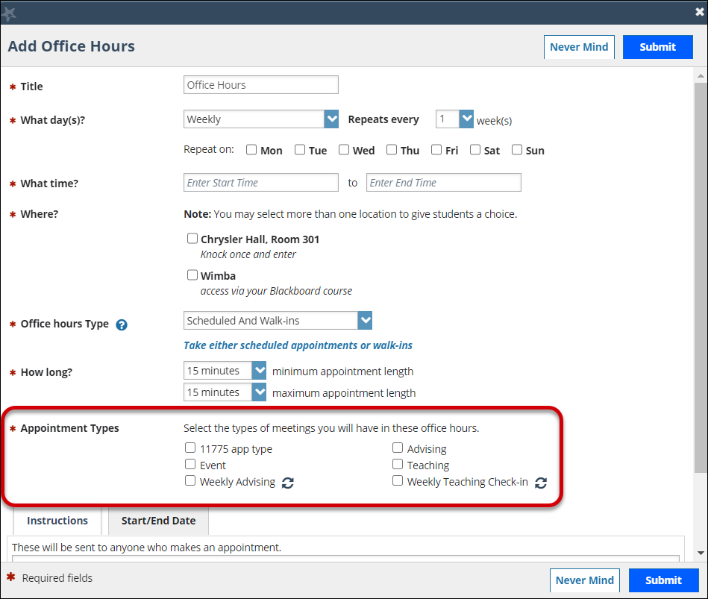
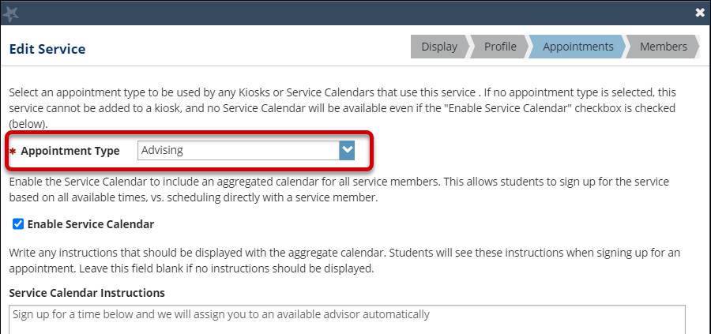

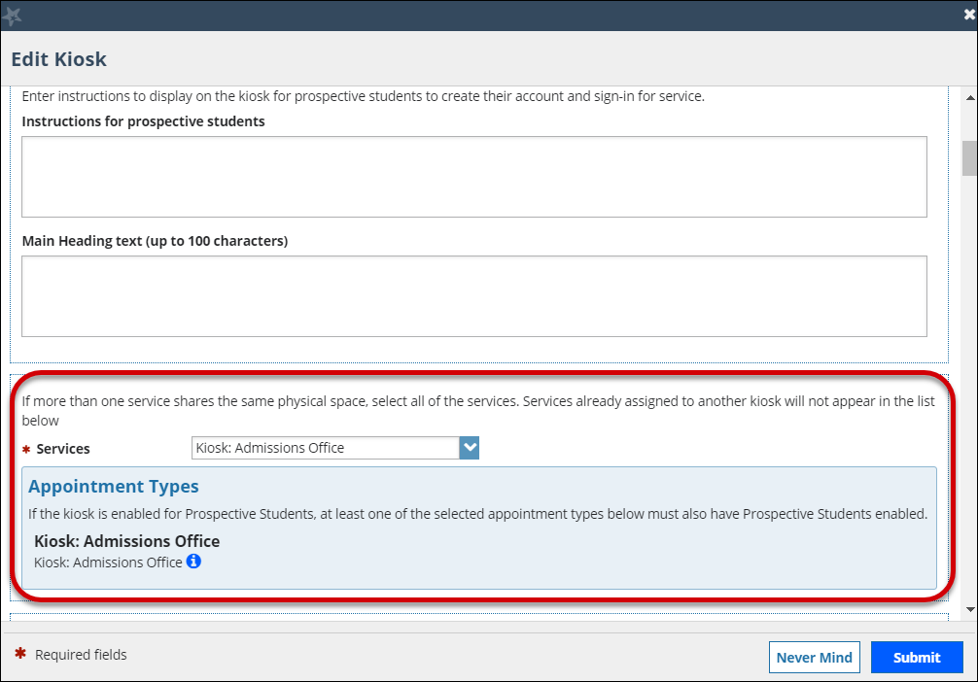

SpeedNotes Tab

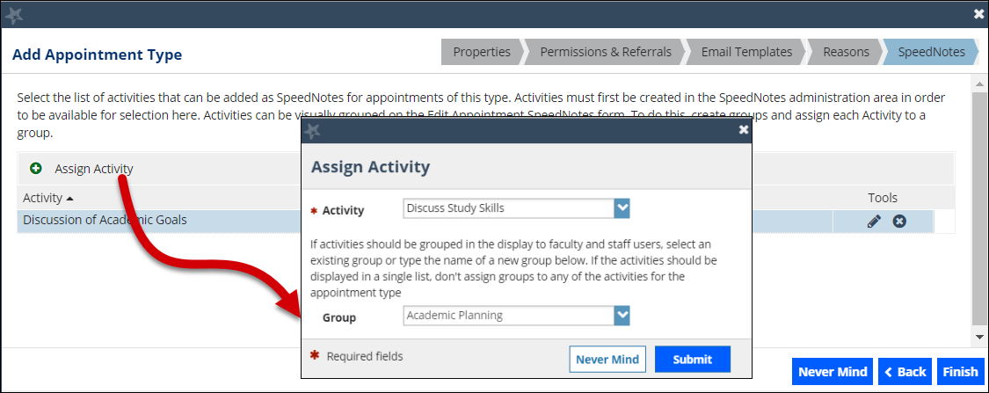
- (Optional) Select +Assign Activity to add a SpeedNote (also called appointment activities). (For more information, review the Guide to SpeedNotes.)

- Select the Activity.

- (Optional) Select or create a Group to help organize the way your SpeedNotes display to faculty and staff. To create a group, simply type the desired group name in the Group dropdown. The new group will auto populate in the dropdown for future use.

- When finished, select Submit.

Where Do SpeedNotes Display in the Service Calendar?

SpeedNotes display on the Edit Appointment Screen. The SpeedNotes (appointment activities) associated with an Appointment Type will display to end users when they track Outcomes of an appointment.
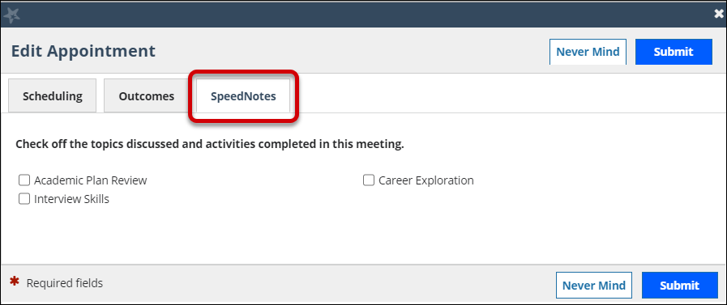

Configure Services

The Appointment Type associated with a Service will determine what data is included when running a Service Report for that Service.
When the Service Calendar is enabled, the appointment type will determine which of the service members’ office hours will pull into the aggregated calendar for the service.

How Do Service Members Display in a Service?

By default, Service Members display by start time, then by duration (shortest duration first), then by alpha order by first name. However, Starfish Admins can contact Starfish Support to turn on the Service Provider Randomization feature. With this feature turned on, Service Member displays by start time, then by duration (shortest duration first), then by first name randomly.
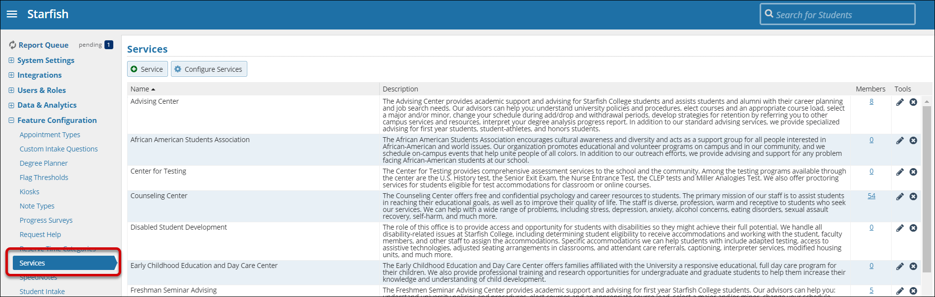
- Navigate to Starfish Admin > Feature Configuration > Services.

- Select + Service to create a new service or select the Edit icon to modify an existing service.

Display Tab

- Enter a Service name for the Service and select the checkbox to Enable the service. If the box is unchecked, the service is not viewable to end users.

- Select where you want this service to display (you may choose more than one option).

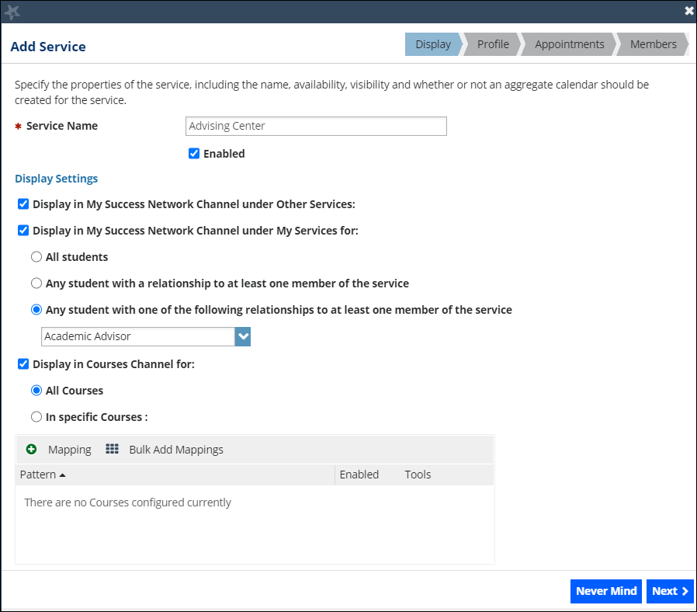

Display Settings
Item | Description
Display in My Success Network Channel under Other Services | This option will list the service in your Service Catalog. Other Services are searchable to the student using keywords or by searching for the service member’s name.
Display in My Success Network Channel under My Services for  Tip: Choose three or five key services to display to students in the My Success Network channel. So, you are not crowding the student homepage with too much information. The remainder of your available resources can be displayed in the Other Services. | All Students: If selected, this service displays for all students.  Any student with a relationship with at least one member of the service: If selected, this service displays for any student with a membership with at least one member of the service.  Any student with one of the following relationships to at least one member of the service: If selected, choose the appropriate member of the service.
Display in Courses Channel for  Tip: Starfish recommends displaying services that are course-based, like Tutoring or Supplemental Instruction. | All Courses: If selected, this service displays in all courses the student is taking.  In Specific Courses: If selected, this service displays in specific courses the student is taking.
Add Mapping/Bulk Add Mappings | Add Mapping: If selected, you have the option to enter entire course IDs, or partial course IDs with wildcards (*).  Bulk Add Mappings: If selected, you can add many courses at once.

- When finished, select Next.

Profile Tab

- In the Photo field, select Browse to search for a photo the service, then select Upload Now.

- In the Description field, enter a description of the service so students know how this service can help them succeed.

- Enter contact information such as Phone, Email, Website, Location and Hours.

- When finished, select Next.

Appointments Tab

Select an appointment type to be used by any Kiosks or Service Calendars that use this service. If no appointment type is selected, this service cannot be added to a kiosk, and no Service Calendar will be available.

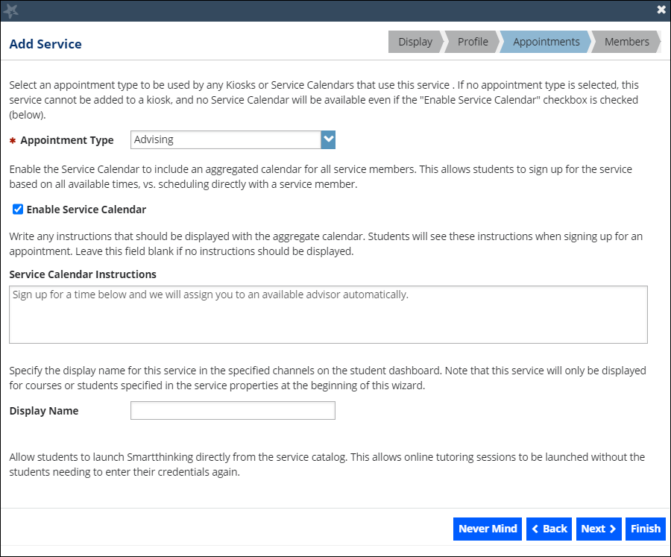
- Select the Appointment Type that should be associated with the service calendar.

- Check the box to Enable Service Calendar.

- Enter any special instructions for the Service Calendar Instructions that should be displayed to students in the service calendar.

- Modify the Display Name if you want something other than the service name displayed to students.

- When finished, select Next.

Members Tab

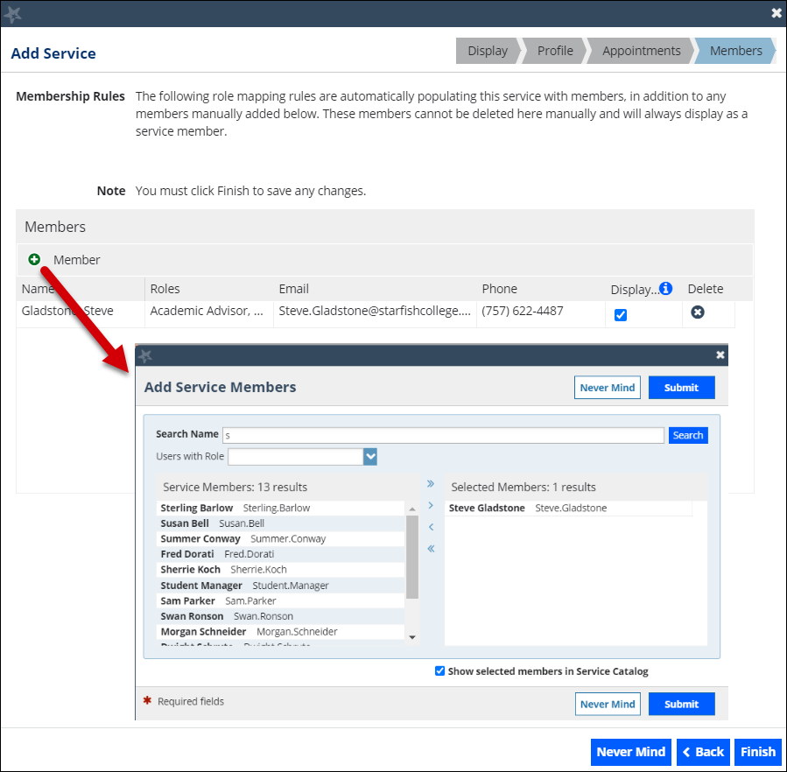
- Select +Member to add the Service Members.
Tip: Since students will see the members of the service and their profile information, service members are encouraged to add a profile photo and complete their Biography and General Overview in the Profile.

- Search by Name and/or by Role to find users.

- Use the > or >> buttons to select users from your search results.

- By default, Show Selected Members in the Service Catalog is selected. When selected, these users will display in the Service Catalog. If those users should not display, uncheck this box. Hiding some Service Members can be useful when adding Service Members such as front desk workers to the Service who need access to manage a Waiting Room but should not display to students as members of that Service.

- Repeat these steps, as necessary. When done, select Finish.
Troubleshooting: By design, any Service Member that has office hours for the appointment type linked to the Service displays in the Service Calendar even if the Service Member is marked as hidden.

Tip: From the Members page, you can manage the Service Members who display in the Service by using the checkbox in the Display column.
However, if a Service Member was added using Role Mapping, you will notice that the Service Member is grayed out not allowing you to manage the Display column. You can get around this by manually adding the Service Member on the Members page. Starfish will override the role mapping. Once you click Finish, you will notice that you can now manage the Display column and hide the Service Member. Be sure to select Finish when you are done.

Note: Starfish supports Direct Links to allow for better nudging of students to act. You can configure student messages to allow for direct links to services or scheduling with services. Faculty/Staff can also grab their personal link to their calendar and add it to their email signature to make it easier for students to schedule time with them.
Key Concept: For students to be able to schedule with Faculty/Staff based on their calendar link, the Faculty/Staff needs to be “searchable” by the student in their Success Network. This is accomplished either by the setup of their role or by being listed as a member in a service that is listed in the Success Network.

Role Mapping

If you are using Role Mapping to prepopulate the members of certain services, you will see an indication under Membership Rules above the list of service members.
For more information on Role Mapping, search for Role Mapping in the Starfish Help Center or review the Guide to Roles and Relationships.
Tip: Please note that if a Service Member was added using Role Mapping, you will notice that the Service Member is grayed out on the Members page not allowing you to manage the Display column.
You can get around this by manually adding the Service Member on the Members page. Starfish will override the role mapping. Once you click Finish, you will notice that you can now manage the Display column. Be sure to select Finish when you are done.

Configure who can view the Services Catalog

You can manage the display of the Service Catalog by selecting Configure Services.
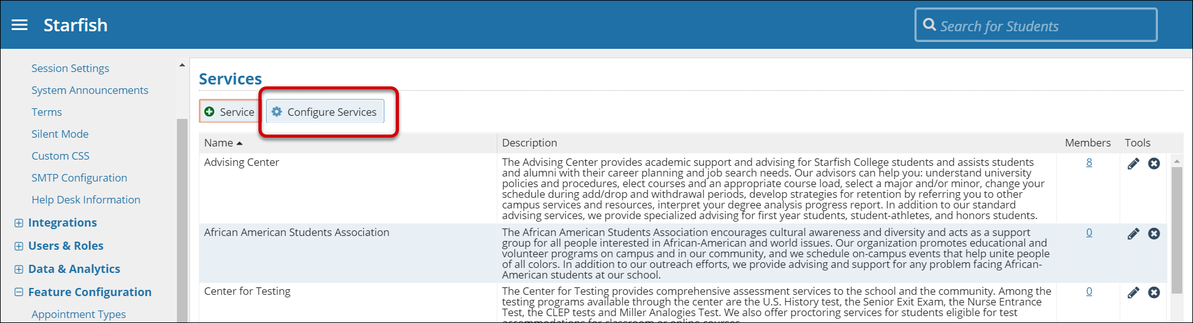
You may decide separately for students and non-students whether the catalog should be displayed or hidden. The default is to display the catalog to both students and non-students. When finished, select Save.
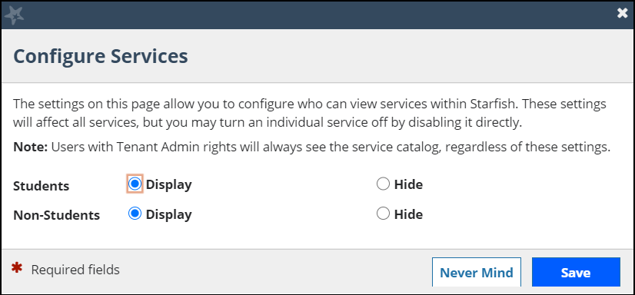

Can I determine the order of Services that display in the Services Catalog?

You can determine the order of the Services that display in the Services Catalog by entering a name (alpha, numeric, or both) in the Service Name field.
Key Concept: Services display in alphabetical order by Service Name.
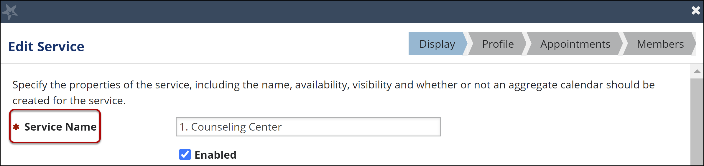
However, names that start with numbers display before names that begin with letters. In the example above, we entered a number before the name of the service.

Now, the service is displayed first preceded by the remaining (alphabetized) services.
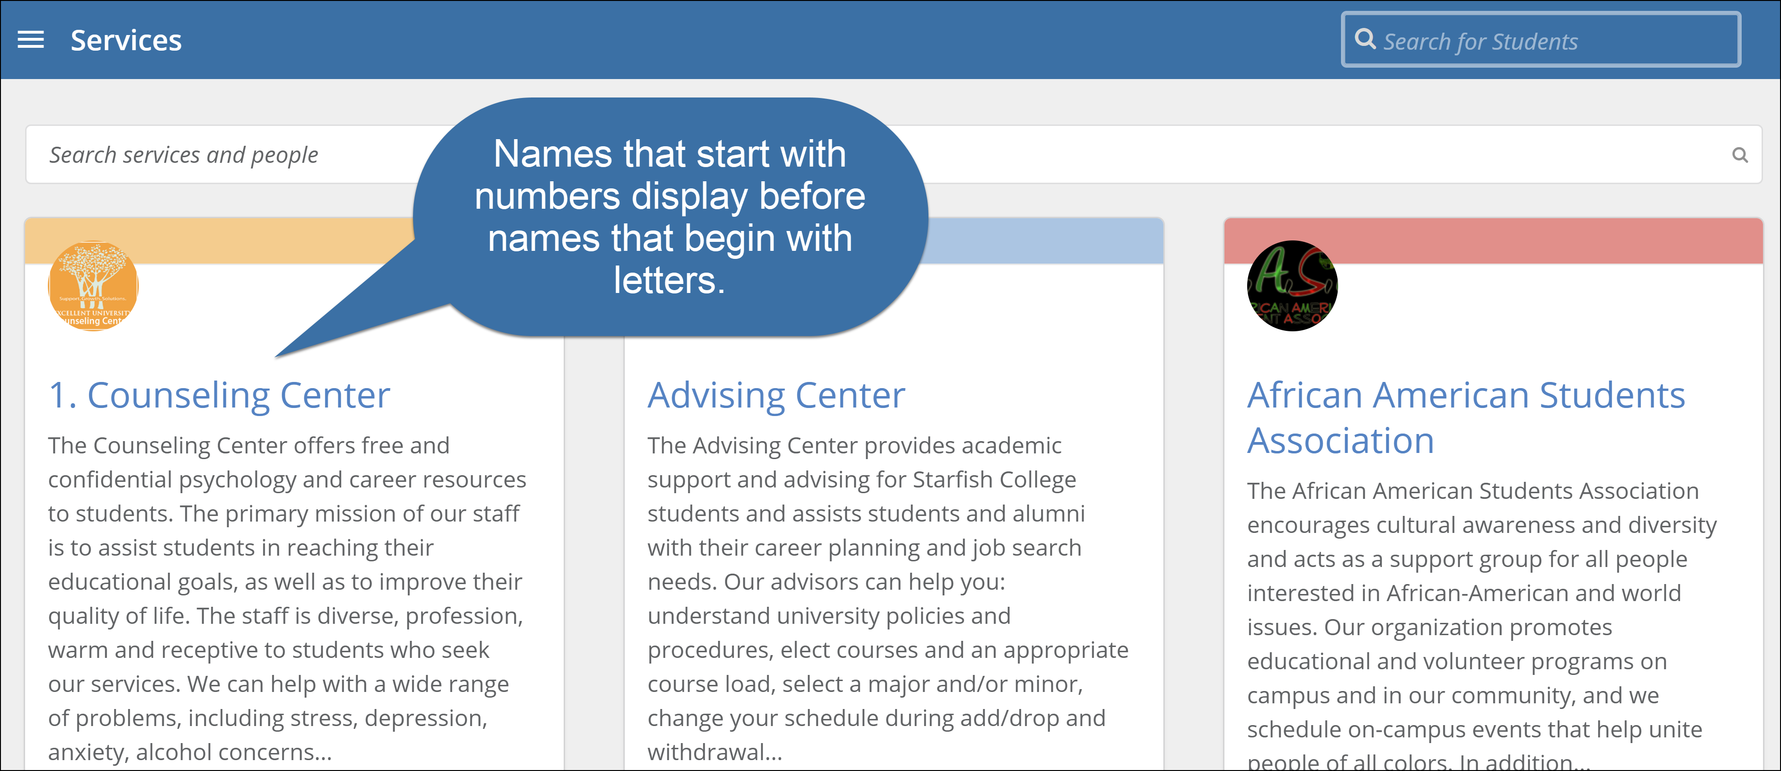
Faculty/Staff Experience viewing the Service Catalog
If you enter a name in the Display Name, the card is sorted alphabetically by Service Name then the Display Name is shown in parenthesis for faculty/staff.
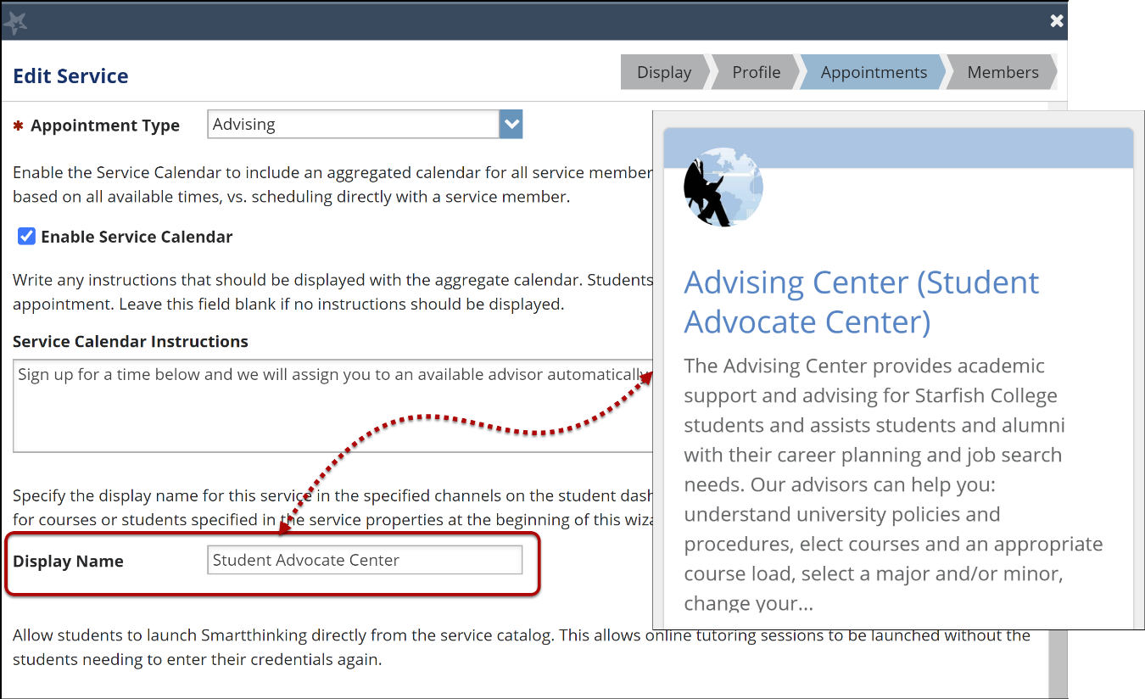
Student Experience viewing the Service Catalog
If you enter a Display Name, the card is sorted alphabetically by Service Name however, only the Display Name is shown on the card for students.
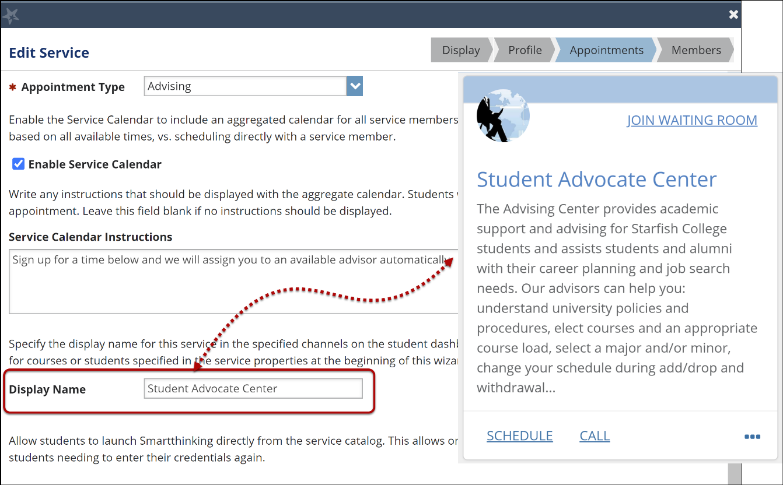
Using the example above, the order student’s see the cards in the Service Catalog is displayed.
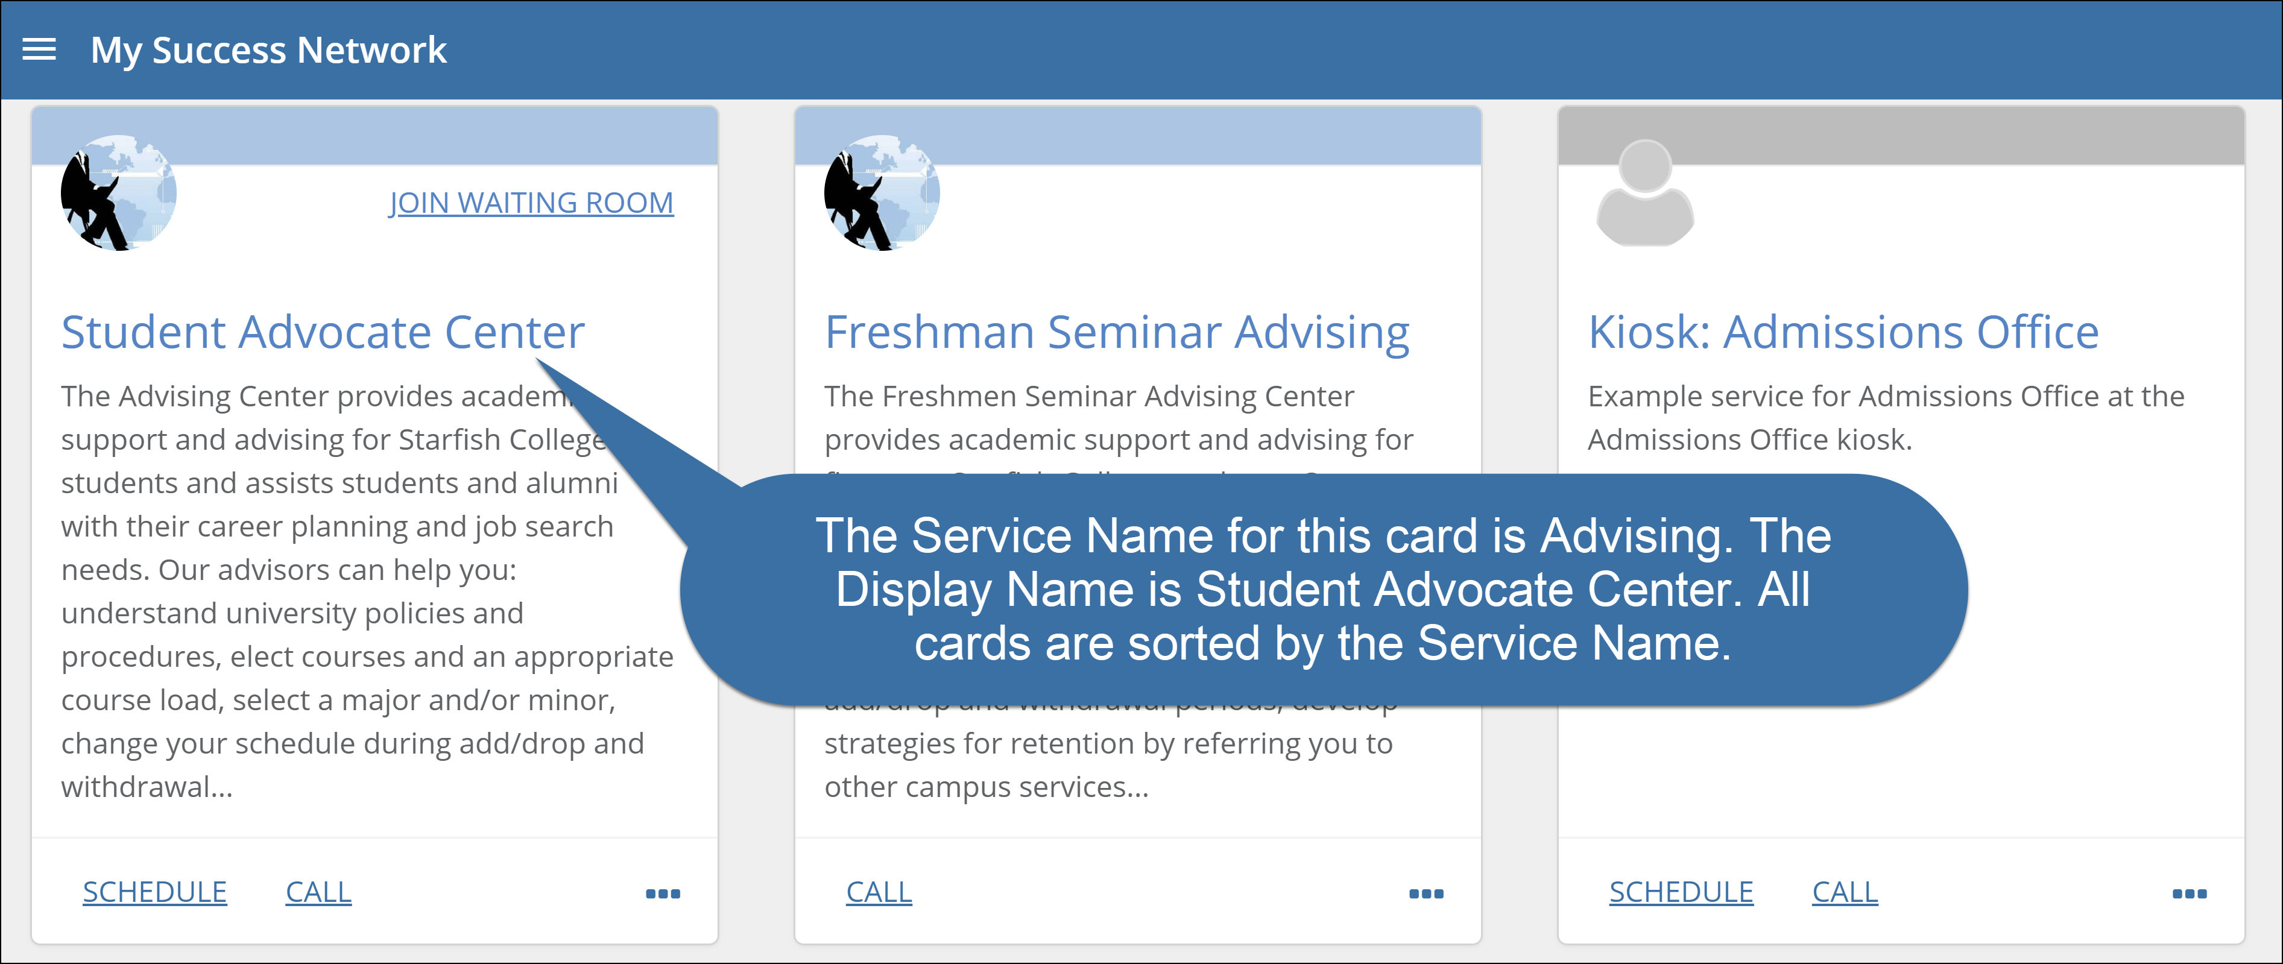

Integration with Microsoft Exchange or Google Calendar

Integrating Starfish with Exchange or Google Calendar allows your end users (calendar owners) to directly share their external schedule with Starfish, so calendar availability is automatically sent to Starfish.















Poll for shared calendars
Starfish
Starfish Exchange
or Google Integration
External Calendar
Push free/busy to display on calendars

How does integration with Microsoft Exchange work?
Starfish communicates with your Exchange environment using the Exchange Web Services (EWS). These web services are available in Exchange 2007, 2010 and 2013. It only queries for a user’s availability, aka Free/ Busy information, if they have specifically turned this feature on for their account (i.e., this is opt-in for end users).
Once a user has shared their calendar with Starfish in Exchange and in the Starfish system, Starfish will establish a subscription to their Exchange Calendar. Your Exchange system will issue notifications to Starfish each time that user’s calendar is modified. Starfish processes these notifications and determines the updated Free/Busy information based on the unique IDs of the items that have been modified. This allows Starfish to keep in sync with Exchange in near real time preventing users from being double booked.
The Starfish Exchange Data Service does NOT require access to your database, or other internal systems. It also does not require that you install any software within your datacenter. But it does need to have an account on your Exchange Server which it can use to issue the Web Service requests, and the username, password and Windows domain for the account must be provided to Starfish.
How does integration with Google Calendar work?
Starfish communicates with the Google Calendar for your faculty and staff using the Google private Calendar URLs. When a user turns on this feature and shares their private calendar URL, Starfish connects to it to retrieve a user’s availability, aka Free/ Busy information.
Once a user has shared their calendar with Starfish by retrieving their Google Calendar URL and pasting it in their Starfish preferences, Starfish will look for updates to their Google Calendar every two minutes.
The Starfish Google Calendar Integration does NOT require access to your database, or other internal systems. It also does not require that you install any software within your datacenter. But it does require that you allow your users to share a private URL for their Google Calendars. A Google apps admin can change this setting to allow users’ calendar information to be shared. The Starfish Google Calendar Integration maintains security of sensitive data in several ways:
- All data communications between Google Calendar and Starfish are over HTTPS.
- Users must turn on the feature within Starfish before the system will attempt to collect information about them.
- Users can turn off the feature at any time and if they do, Starfish does not keep their private URL.
- Users can change their private URL on their Google Account to disable the old URL at any time.
